 |  | 

CONDITION BASED ASSESSMENT
QUICK SCANNING REPORT
SBUM DIAGNOSTIC JOHOR
TNB BAHAGIAN PEMBAHAGIAN JOHOR

FUNCTIONAL LOCATION (ERMS) | : | JJBU/PCE/H01031
FUNCTIONAL LOCATION (SITE) | : | JJBU/PCE/H01031
SUBSTATION NAME (ERMS) | : | TAMAN ULAM RAJA
SUBSTATION NAME (SITE) | : | TAMAN ULAM RAJA JOHOR BAHRU
COORDINATE | : | 1.579336, 103.718377
SUBSTATION TYPE | : | PCE
AREA | : | JOHOR BAHRU
STATE | : | JOHOR
PO | : | 42234207
DATE | : | 14 JUL 2026
SCANNED BY
THERMOGRAPHY | : | MUHAMMAD OMAR RIDZUAN (2013MY20N010)
EQUIPMENT/TOOLS
THERMOGRAPHY | : | FLIR T640 (SN 55912229) (CALIBRATION DUE DATE: 26 DEC 2026)
PREPARED BY
NAME OF CONTRACTOR | : | EET ENGINEERING SERVICES SDN BHD
ADDRESS | : | NO.38, JALAN SS19/1D,
 | : | 47500, SUBANG JAYA, SELANGOR.
SUBSTATION SIGNBOARD
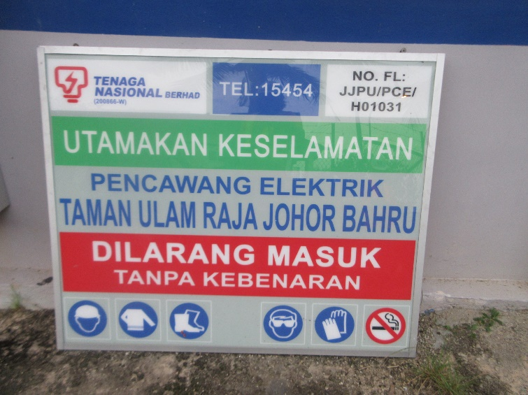

visual defect Summary
NO. | EQUIPMENT | DEFECT DESCRIPTION | ELECTRICAL | NON-ELECTRICAL
1 | SUBSTATION | NO PADLOCK – SWG ROOM |  | X
2 | RUBBER MAT | NO RUBBER MAT |  | x

SUBSTATION CONDITION

SUBSTATION OVERVIEW |  | SIGNBOARD
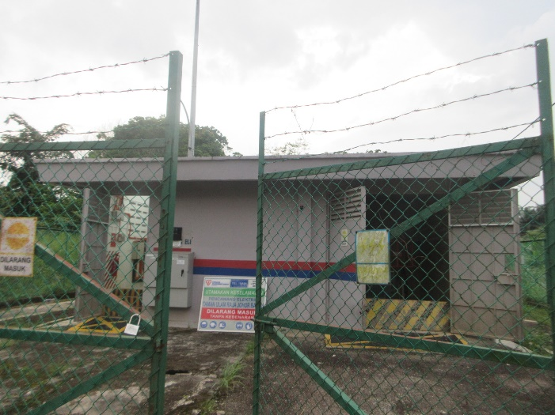 |  | 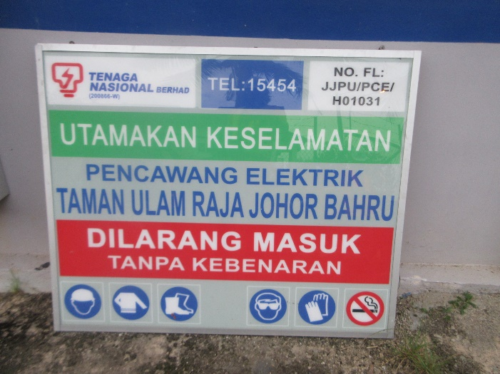
SWITCHGEAR |  | SWITCHGEAR NAMEPLATE
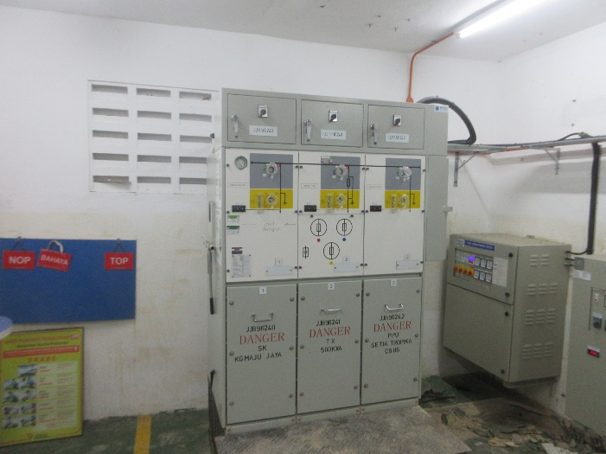 |  | 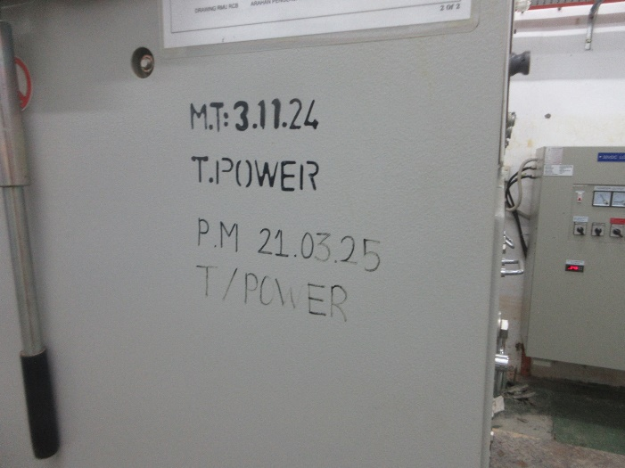
TRANSFORMER 1 |  | TRANSFORMER 1 NAMEPLATE
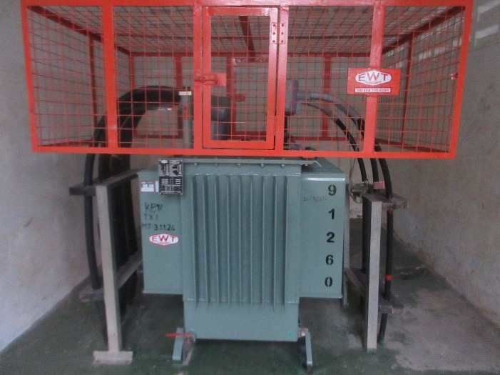 |  | 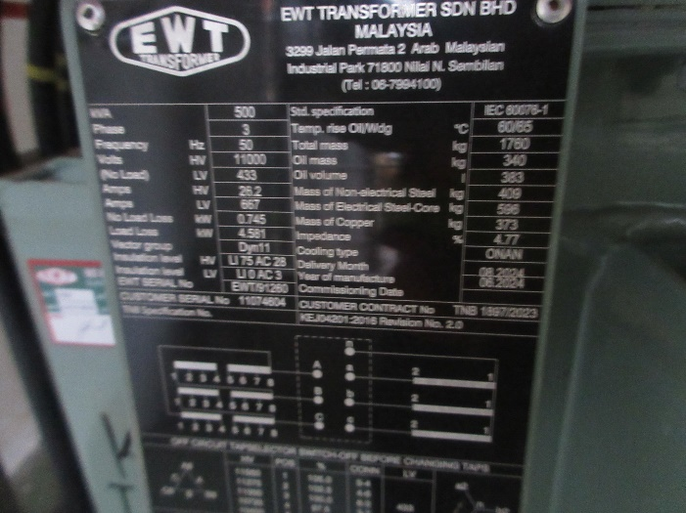

SUBSTATION CONDITION

TRANSFORMER 2 |  | TRANSFORMER 2 NAMEPLATE
N/A |  | N/A
LVDB TX1 |  | LVDB TX1 NAMEPLATE
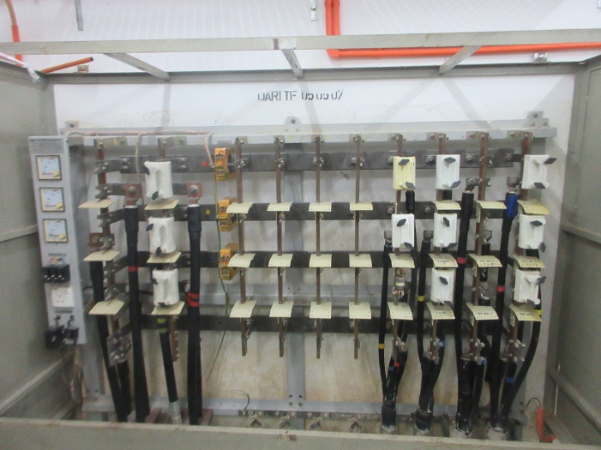 |  | 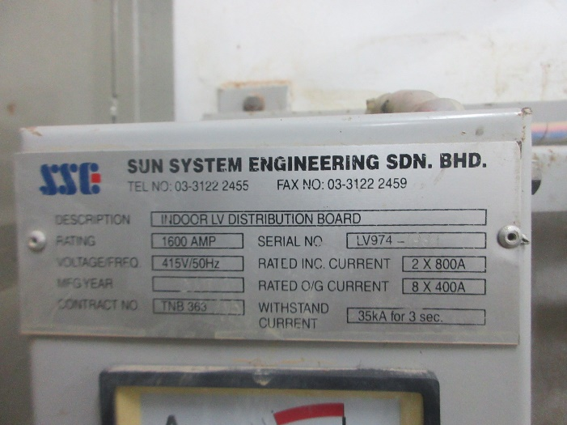
FEEDER PILLAR TX2 |  | FEEDER PILLAR TX2 NAMEPLATE
N/A |  | N/A
SUBSTATION CONDITION

EFI |  | SF6 INDICATOR
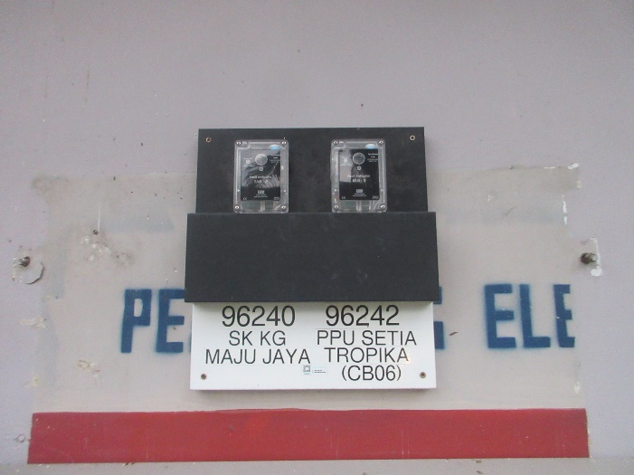 |  | 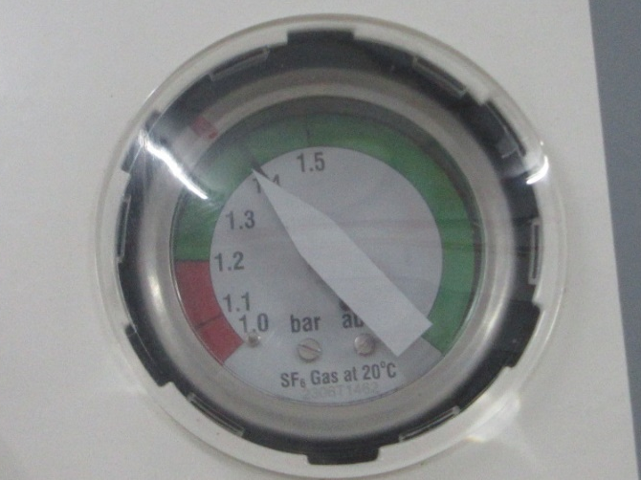
BATTERY 1 |  | BATTERY 1 NAMEPLATE
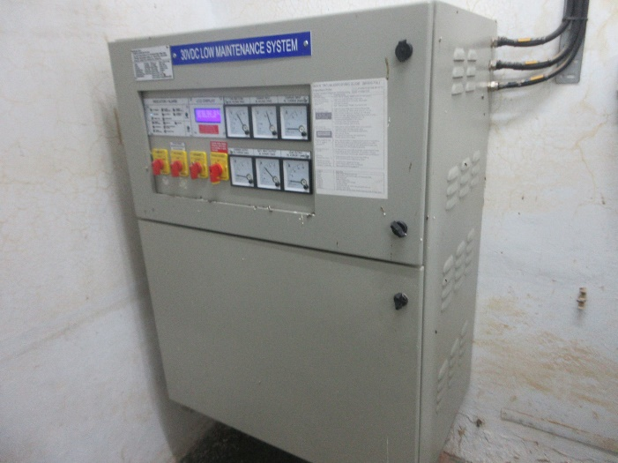 |  | 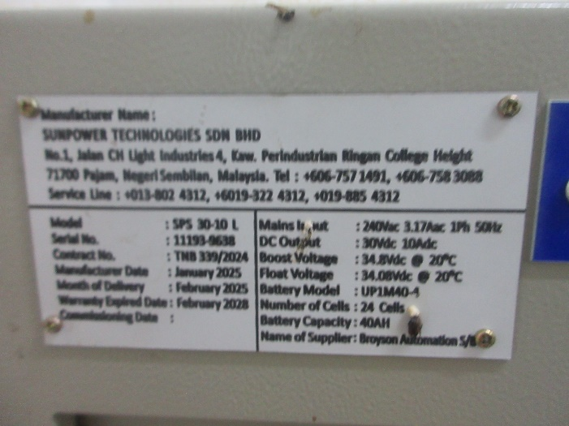
BATTERY 2 |  | BATTERY 2 NAMEPLATE
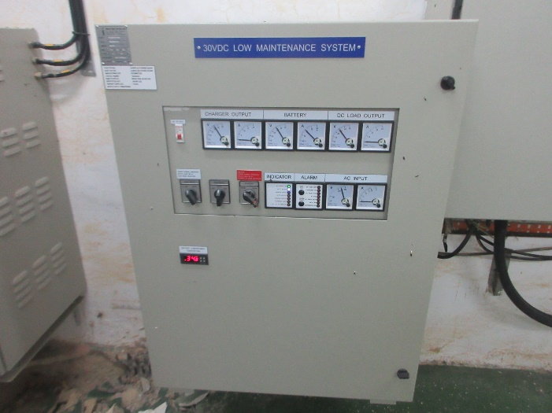

SUBSTATION CONDITION

FIRE EXTINGUISHER |  | FIRE EXTINGUISHER NAMEPLATE
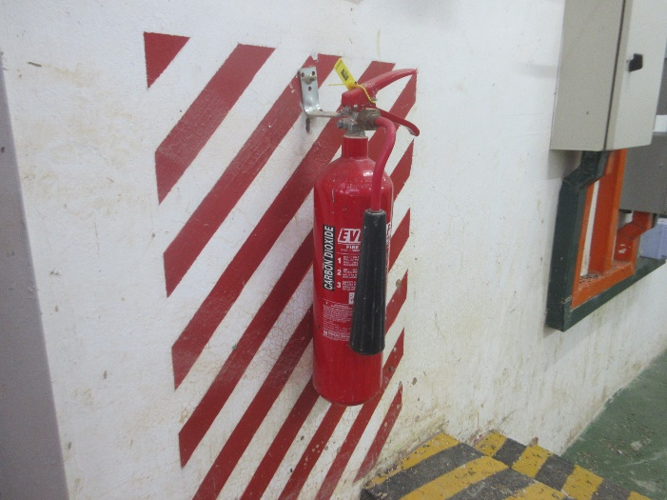 |  | 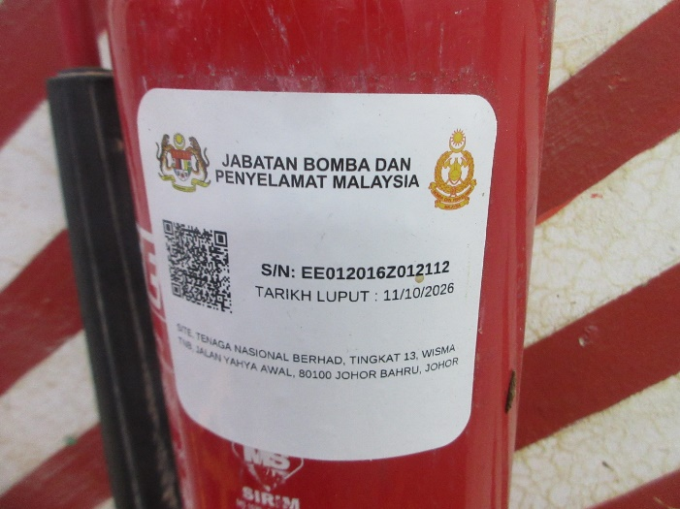
SWITCHGEAR PANEL NAME |  | LAST PREVENTIVE MAINTENANCE
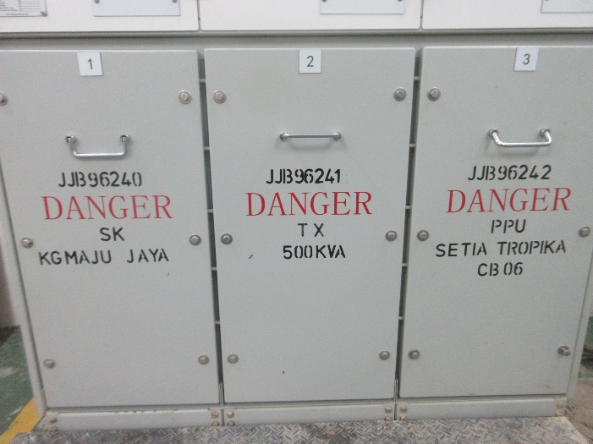

VISUAL DEFECT

RUBBER MAT |  | SUBSTATION
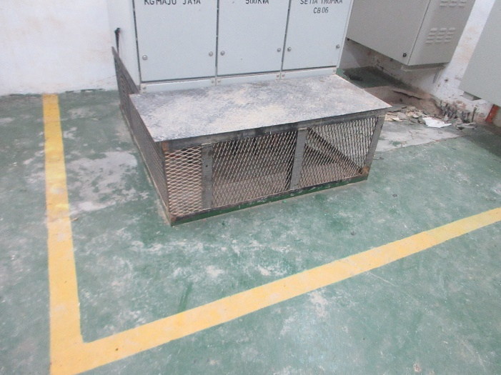 |  | 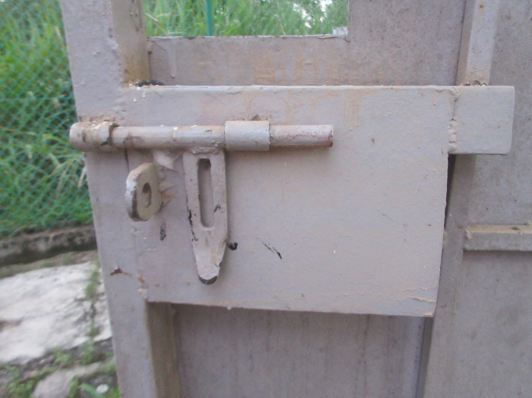
NO RUBBER MAT |  | NO PADLOCK – SWG ROOM

NORMAL/DEFECT STICKER

NORMAL STICKER
